Group: A
Meeting Number: 2
Date and Time: 19/01/2026: 19:00

Present:
Balraj Bhuller
Christopher Mead
Hannah Arnold
Max McGill
Rachel Kirkham

Items for discussion:

Prepare for validation meeting on the first week back of university, 27/01/2026.

Discuss a rough basic idea on the Soapamorph prototype design, constraints and functionality.

Record of discussion
Foam sheets – mould head.  - 3d Scan for 3d printing or use the haptic pen. | 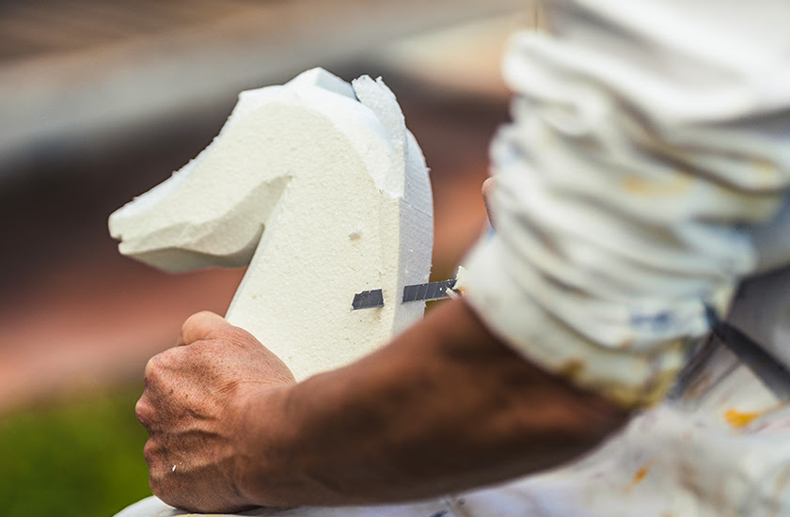
Peristaltic Pump  - Blender design for the mouth tongue track.  - One way pump motion. | 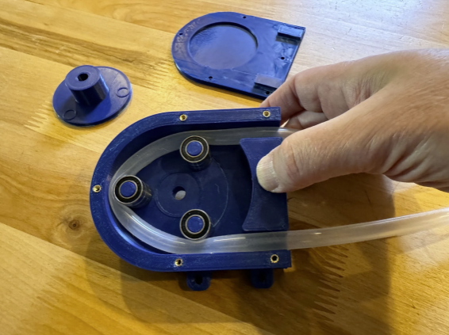
Track motion for inner head  - Gear track – for movement  Or linear actuator | 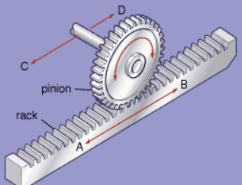
Silicone | Coating or base to keep bacteria out.  Non – porous surface meaning little opportunity for bacteria to anchor. Doesn’t cancel the risk fully of bacteria lingering however its more efficient at keeping bacteria at bay.  Easier to clean and maintain.

Processes to show:
- Blender design.
- 3d printing.
- 3D Scanning or Pen Haptics.
- Possible silicone processing for anti-bacterial design.
- Last but not essential, electronic design and implementation.
Key things to consider:
- Possible skeleton design if silicone base.
- Non-hollow tongue for tube alignment.
- Attachable tongue for cleaning.
- Electronics not coming into contact with moisture or soap.
- Electronics pushed back to the end.
- Weighted base – Metal attachment around the base to secure weight
- Electronics not being lower than the soap just in case of leakages.

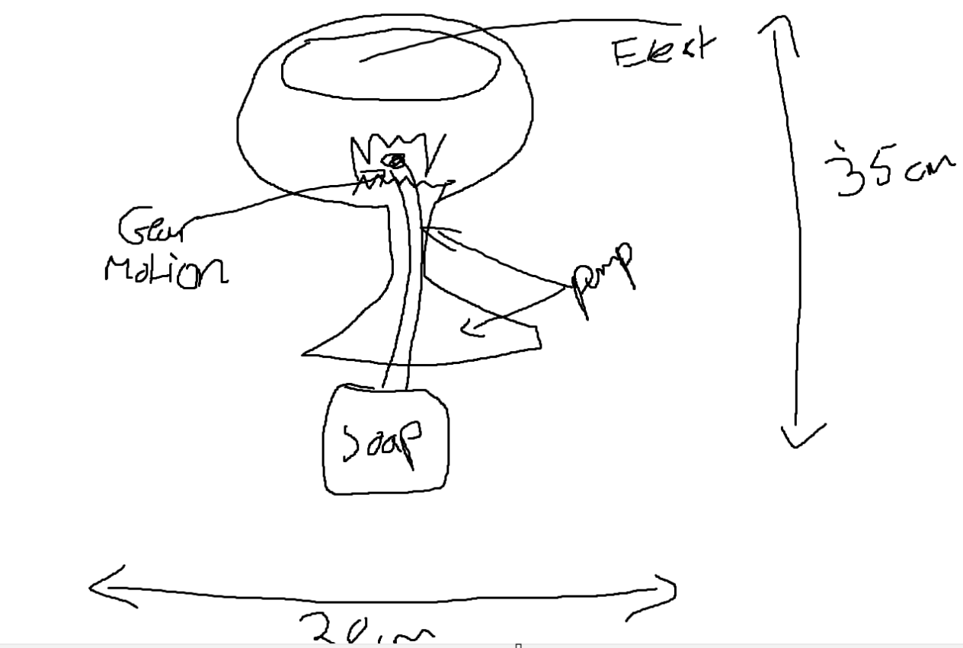
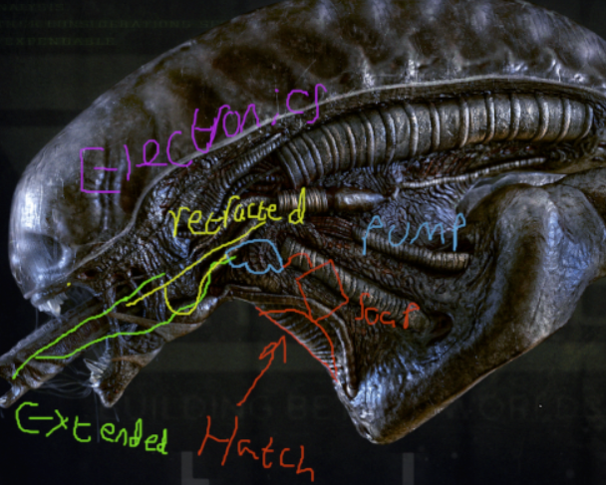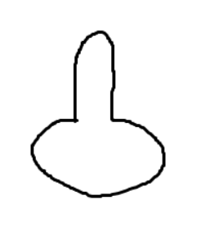

Next Steps:
Action No. | Action Required | Success criteria | By When | By who
1. | Individual research: What motion techniques to use for the tongue mechanism. | 100% | 27/01/2026 | ALL
2. | Individual research: What pump method and materials would be best other than what we discussed. | 100% | 27/01/2026 | ALL
3. | Individual research: Material research for entire model base, justified why it would work better than what was discussed or why what is discussed works best. | 100% | 27/01/2026 | ALL
4.
5.
6.

